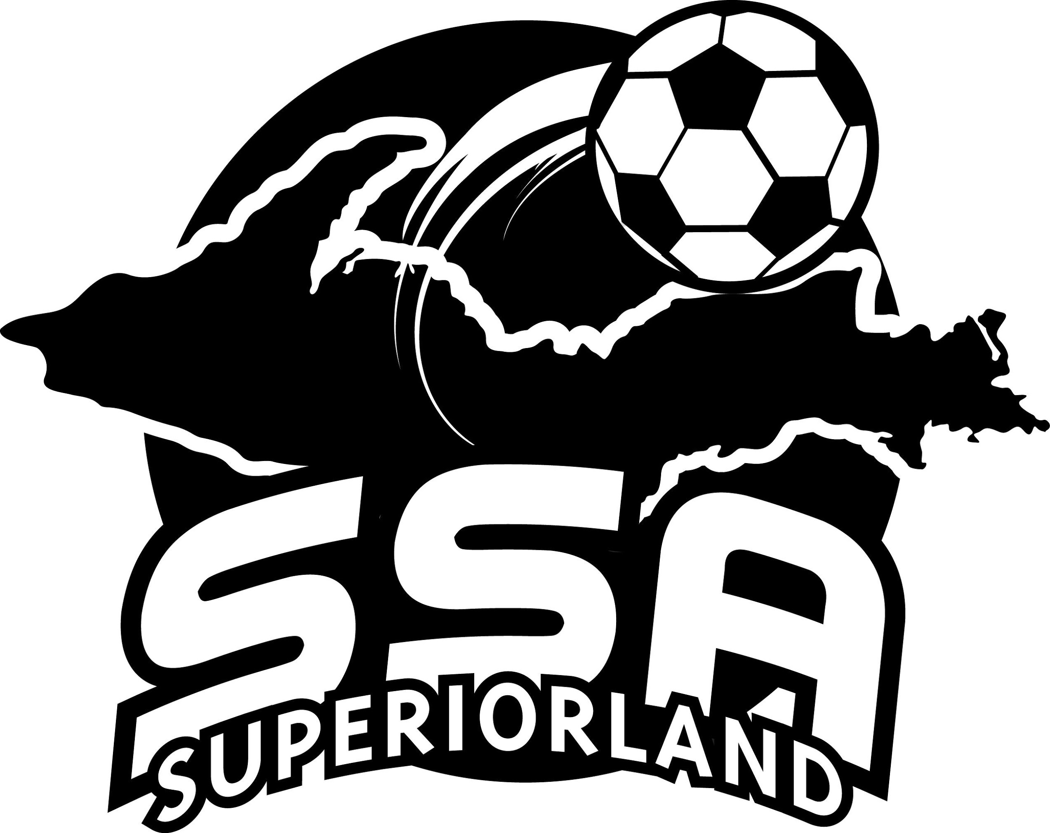
SSA is taking on a new initiative to improve the sport of soccer in the Upper Peninsula. Coming advancements will bring the U.P. in line with national standards, and develop soccer into an avenue for local youth to have fun.

Our Recreational League is intended to introduce players to the sport, build relationships, and help youth athletes develop life skills necessary to succeed both on and off the field.

Some of the improvements include:

- Adjusting the age divisions to U7, U9, U11, U13, U15, and U19 so they align with state and national standards.
- Our U7 Developmental Program will include players born on or before June 30, 2016. They will be divided into 2 groups based on age and ability.

Divisions | Player Date of Birth Years
U7 Coed Developmental Program (formerly Little Kickers) | 1/1/2014-6/30/2016
U9 Coed and U9 Girls | 1/1/2012-12/31/2013
U11 Coed and U11 Girls | 1/1/2010-12/31/2011
U13 Coed and U13 Girls | 1/1/2008-12/31/2009
U15 Coed | 1/1/2006-12/31/2007
U19 Coed | 1/1/2002-12/31/2005

- Streamlining the Recreation League season to include eight weeks of play with a break during the week of Independence Day Holiday, 6/28/2021 -7/1/2021. All teams in any given age division will have the same training day, and game day each week. This will simplify schedules for parents and players.

- Hosting weekly Group Training and pregame warmups led by SSA certified coaches following the curriculum developed by our Director of Coaches, Sasa Kostic. This will ensure every player is able to participate and learn appropriate skills and terminology—regardless of what team a player is on, or previous experience.

- Team formation will be based upon players’ self-reported skill level from the registration form. This is intended to help create balanced teams throughout each division. If necessary, SSA may make roster changes as the season progresses.
Registration is open now through April 5, 2021. League play starts June 14, 2021 and runs through August 5, 2021.

More information available at:
WWW.SUPERIORLANDSOCCER.COM
WWW.FACEBOOK.COM/SUPERIORLANDSOCCER

